Five Trends Transforming the Automotive Industry
Source: PwC- 2018

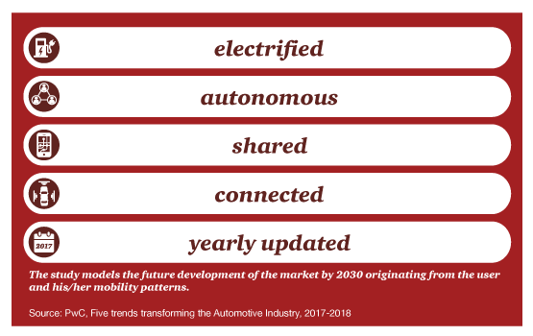
The mobility of the future is “eascy”– electrified, autonomous, shared, connected and “yearly” updated.

Electrified– the transition to emissions-free mobility will become a global requirement. Electricity used to charge vehicles will increasingly come from renewable sources to ensure carbon dioxide-neutral mobility.

Autonomous-- The development of vehicles which require no human intervention will reduce the use of public mobility platforms and offer individual mobility to new user groups.
Shared– Professionally managed fleets of shared vehicles will reduce the cost of mobility by a significant amount through more efficient use of expensive mobile assets.
Connected – This applies in two ways: communication between cars or with traffic management infrastructure or between vehicle occupants and the outside world. The car of the future will become a “third place” between home and workplace, combining features of both.
‘Yearly’ updated – The range of models will be updated annually to integrate the latest hardware and software developments, and react to changing requirements of shared fleet buyers.

